Part Number: PTR03-35161 (XL)

PTR03-35162 (SL)

Kit Contents
Item # | Quantity Reqd. | Description
1 | 1 | Muffler Assembly
2
3
Hardware Bag Contents
Item # | Quantity Reqd. | Description
1 | 1 | Installation Instructions
2
3
Additional Items Required For Installation
Item # | Quantity Reqd. | Description
1
2
3
Conflicts
None
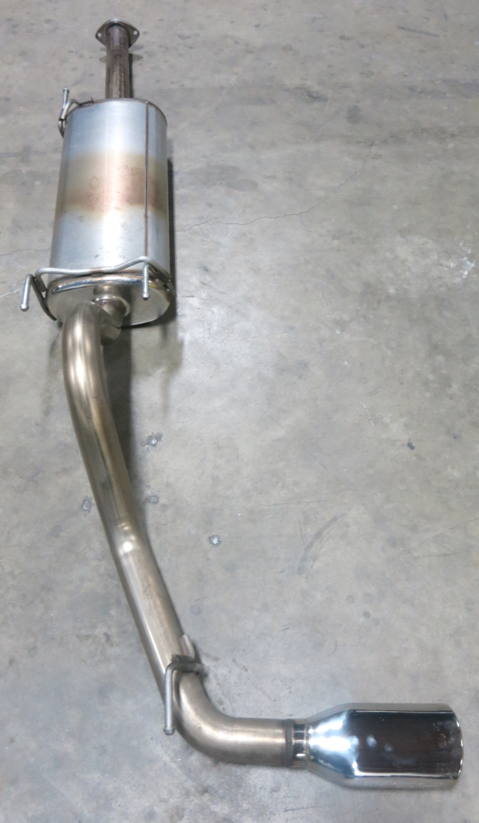
Recommended Tools
Personal & Vehicle Protection | Notes
None
Special Tools | Notes
Exhaust Hanger Tool | e.g. Snap On P/N YA3202
Installation Tools | Notes
Socket | 14 mm
Torque Wrench | 20-100 ft·lb (25-135 N·m)
Special Chemicals | Notes
Lubricant | Soap and Water
General Applicability
PTR03-35161 – Tacoma 3.5L V6 C-Cab Long Bed or Double Cab Short Bed
PTR03-35162 – Tacoma 3.5L V6 Double Cab Long Bed
Recommended Sequence of Application
Item # | Accessory
1
2
3
*Mandatory
Vehicle Service Parts (may be required for reassembly)
Item # | Quantity Reqd. | Description
1 | 1 | 90080-43033 Exhaust Gasket (Not included in Kit)
2
3
Legend
STOP: Damage to the vehicle may occur. Do not proceed until process has been complied with.
OPERATOR SAFETY: Use caution to avoid risk of injury.
CAUTION: A process that must be carefully observed in order to reduce the risk of damage to the accessory/vehicle and to ensure a quality installation.
TOOLS & EQUIPMENT: Used in Figures calls out the specific tools and equipment recommended for this process.
REVISION MARK: This mark highlights a change in installation with respect to previous issue.
SAFETY TORQUE: This mark indicates that torque is related to safety.

Care must be taken when installing this accessory to ensure damage does not occur to the vehicle. The installation of this accessory should follow approved guidelines to ensure a quality installation.

These guidelines can be found in the "Accessory Installation Practices" document.

This document covers such items as:-
- Vehicle Protection (use of covers and blankets, cleaning chemicals, etc.).
- Safety (eye protection, rechecking torque procedure, etc.).
- Vehicle Disassembly/Reassembly (panel removal, part storage, etc.).
- Electrical Component Disassembly/Reassembly (battery disconnection, connector removal, etc.).

Please see your Toyota dealer for a copy of this document

Check the Kit contents.
  - Make sure that the kit contains all the parts listed in the Kit Contents.

Remove the Existing Exhaust System.
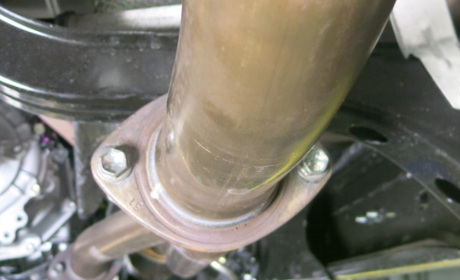
  - Remove the two bolts from the flange located between the catalytic converter and the rear muffler (Fig. 2-1).
Fig. 2-1
Bolts
14mm socket & ratchet
  - Keep all original equipment (OE) bolts and the gasket (Fig. 2-1).
NOTE: For DIO installations, the gasket must be replaced – P/N 90080-43033. Follow the procedure in the factory Repair Manual.
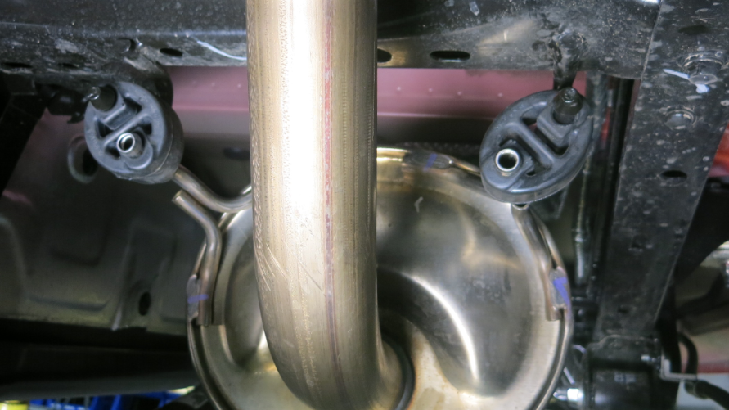
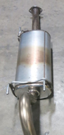
  - Pry the rear muffler exhaust brackets loose from the rubber hangers (Fig. 2-2).
Brackets
Fig. 2-2
Rubber hangers
Exhaust hanger tool
NOTE: Lubrication (such as soap and water) on the rubber exhaust hangers can facilitate removal and installation of rubber hangers.

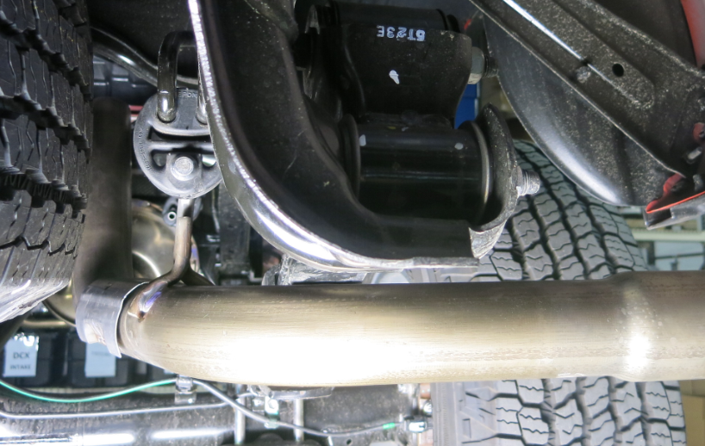
  - Pry the tailpipe bracket loose from the rubber hanger (Fig. 2-3).
Fig. 2-3
Bracket
Rubber hanger
Exhaust hanger tool

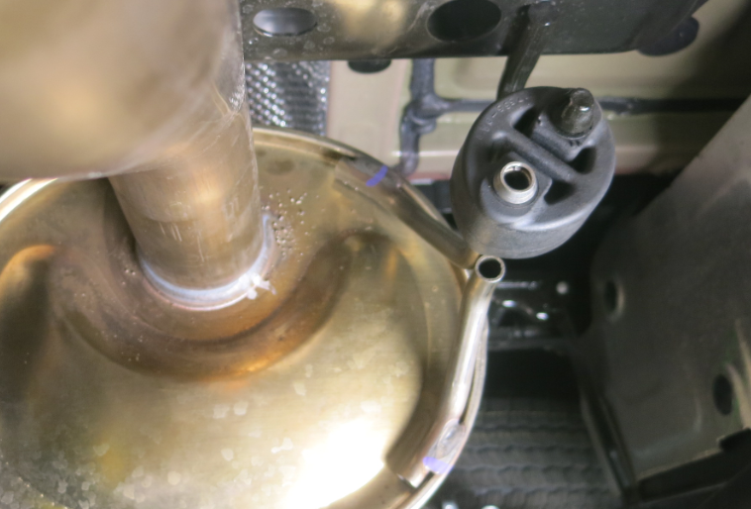
  - Pry the front muffler exhaust bracket loose from the rubber hanger (Fig. 2-4).
Fig. 2-4
Bracket
Rubber hanger
Exhaust hanger tool
NOTE: Do not remove the original rubber hangers (OE) from the vehicle; four (4) in total.
  - Remove the OE muffler assembly from the vehicle.

Install the TRD Exhaust System.
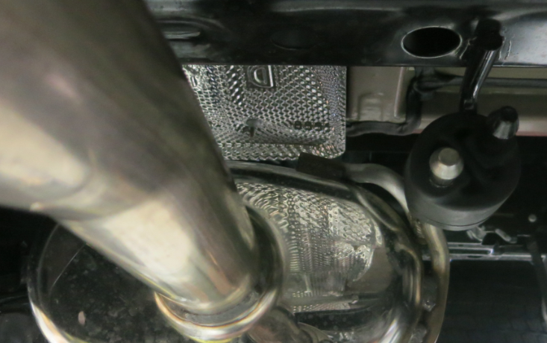
  - Connect the front muffler bracket to the OE rubber hanger (Fig. 3-1).
Fig. 3-1
Bracket
Rubber hanger

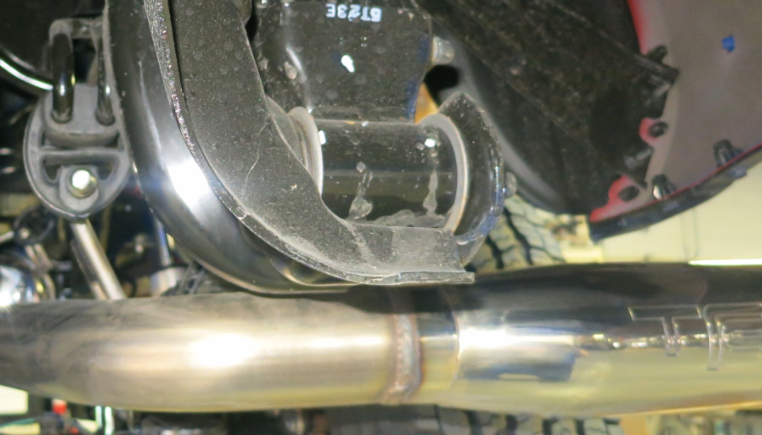
  - Connect the tailpipe hanger to the OE rubber hanger (Fig. 3-2).
Fig. 3-2
Bracket
Rubber hanger
Hanger Removal Tool

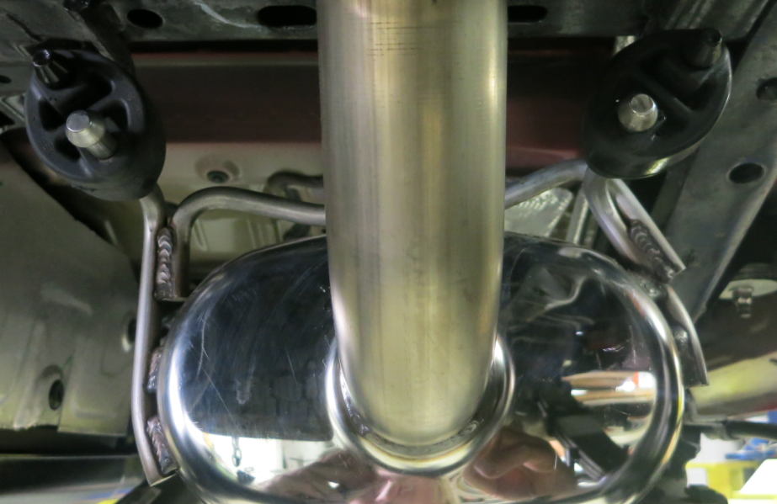
  - Connect the rear muffler hangers to the OE rubber hangers (Fig. 3-3).
Brackets
Fig. 3-3

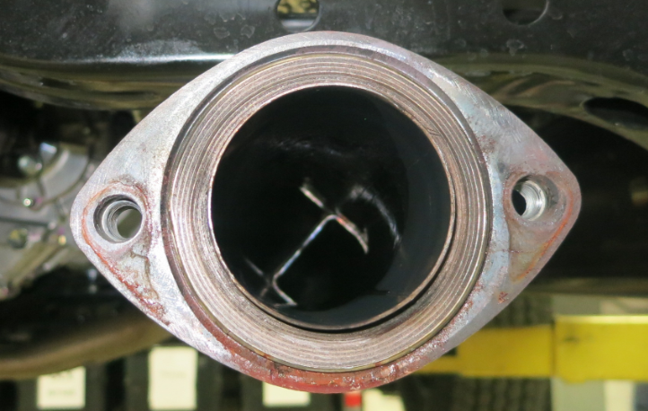
  - Install the exhaust gasket in between the muffler flange and the converter flange (Fig. 3-4).
Gasket
Fig. 3-4

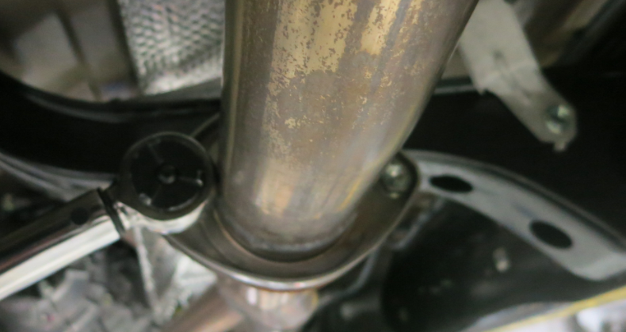
  - Make sure the muffler flange is lined up to the converter assembly flange. Reinstall the two (2) OE bolts and tighten them to 48 N-m (35 lb-ft) (Fig. 3-5).
Fig. 3-5
Bolts
14mm socket & torque wrench
Torque: 48 N-m (35 lb-ft)

Accessory Function Checks
Correct part has been installed.
All joints have been securely fastened.
Hooks/hangers have been securely reattached

Vehicle Function Checks
Bolt torque - muffler to converter assembly

Verify part number on package.
Verify joints are tightened.
Verify hooks/hangers are securely attached.

Torque: 48 N-m (35 lb-ft)

Vehicle Appearance Check
After accessory installation and removal of protective cover(s), perform a visual inspection.

Ensure no damage (including scuffs and scratches) was caused during the installation process.
(For PPO installations, refer to TMS Accessory Quality Shipping Standard.)

